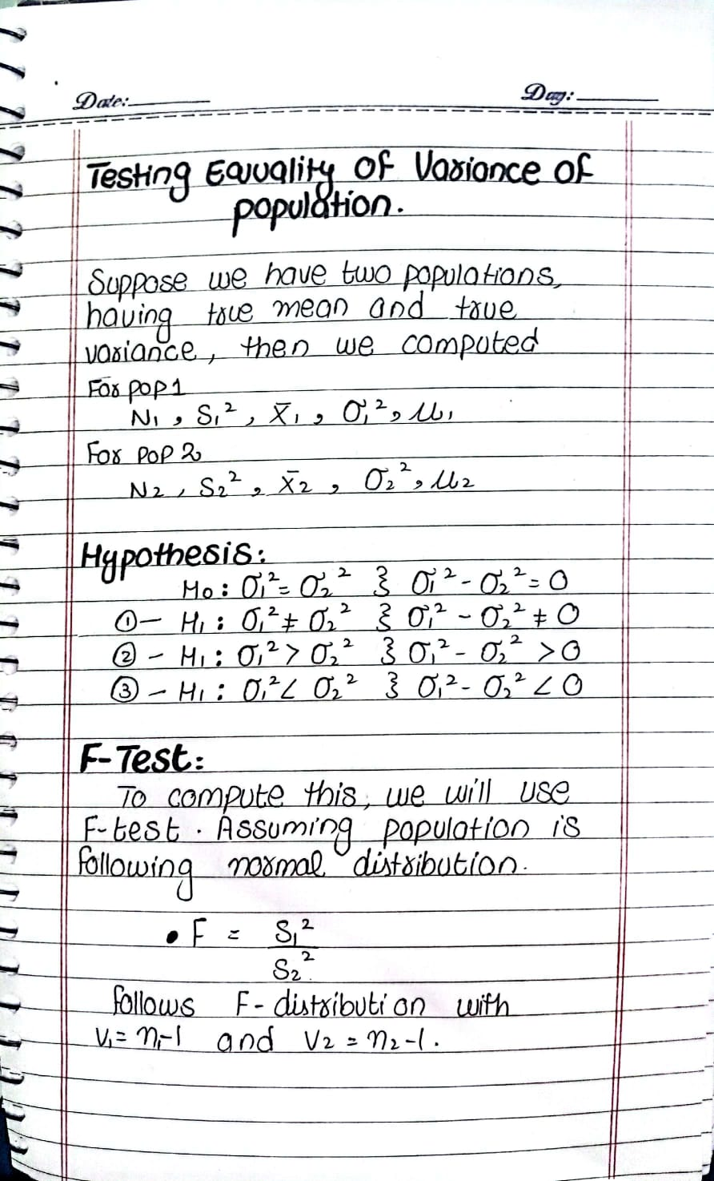
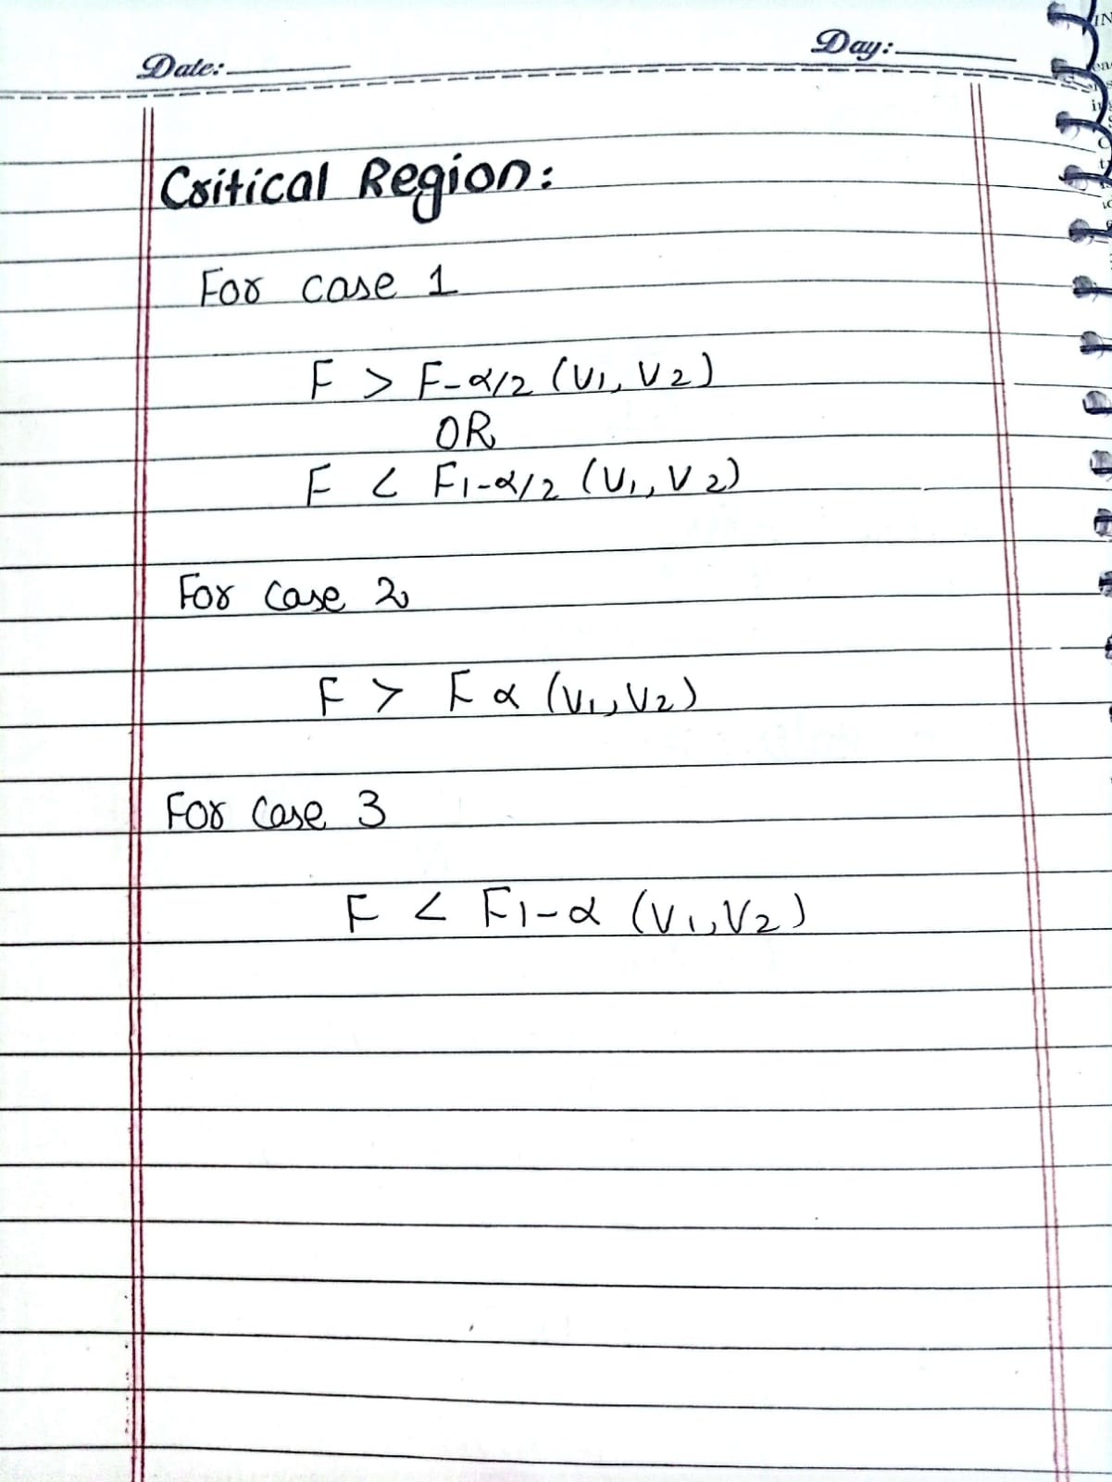

QUESTION:
A company wants to test whether two different machines produce products with the same variance in their output measurements. A random sample of 12 observations was taken from Machine 1, and the standard deviation was found to be 4. Another random sample of 10 observations was taken from Machine 2, and its standard deviation was 5.
Assuming that the variances of the two machines are equal, test the hypothesis at a 0.1 significance level.
Perform an F-test for equality of variances and determine whether the null hypothesis should be accepted or rejected. Show all steps and calculations clearly.
